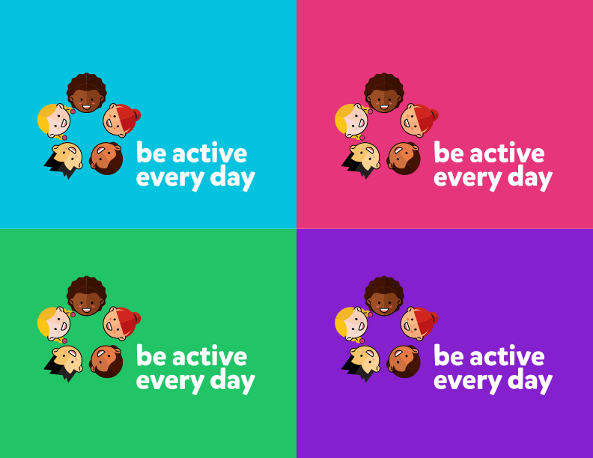

Step-by-Step Instructions & Speaking Notes for Physicians

Contents
INTRODUCTION 3
If you have any questions, please do not hesitate to contact Patrick Higgins, Communications Officer, at phiggins@doctorsofbc.ca or 604-638-8744. Enthusiasm and smiles are the keys to getting kids excited – if you’re excited, they will be too! Start off with some questions to get them engaged and talking about being active. 3
SPEAKING NOTES 4
INTRODUCE YOURSELF AND THE CHALLENGE 4
COVID-19 – PLAY TOGETHER, STAY APART 5
PLAY IT FORWARD 5
COUNTDOWN 5-2-1-0 6
Teach Heart Rate 8
OPTIONAL - SHOW THE FIRST OF FIVE VIDEOS 8
WEEK OF OCTOBER 30 – CELEBRATE CHALLENGE COMPLETION! 9
Hand out Certificates 9
Prize Winners 9
Summarize the Challenge 10

INTRODUCTION
Thank you for participating in the Be Active Every Day (BAED) campaign! Monday, October 5th is the official launch date of the challenge, and kids across BC are excited to learn what they’ll be doing for the next four weeks. Your role in the initiative is to act as a health ambassador and includes:

- Engaging with the kids and encouraging them to do their best
- Describing what kids need to do each day for the challenge
- Ensuring kids get active while adhering to provincial COVID-19 public health advice
- Talking about the 5-2-1-0 guidelines
- Optional - Play the first video of this year’s campaign
- Talk about heart rates – how to check them, how they go up/down and why
- Tell kids about the prize draw where they are automatically in with a chance to win a DELUXE BE ACTIVE BOARD GAME!

The beginning of the month is a critical time for kids to get enthusiastic about the challenge. We encourage you to be passionate, animated, and dress accordingly for the fitness theme. The speaking notes are just a suggestion, you can adjust them to suit your own speaking style.

The following materials are provided to help encourage the students and help them achieve their daily 60 minutes of activity goals:

- Activity Z-cards (a foldable, pocket-sized guide for each student)
- BAED board game that reinforces the campaign messaging.
- Certificate of achievement – given out at the end of the month

If you have any questions, please do not hesitate to contact Patrick Higgins, Communications Officer, at phiggins@doctorsofbc.ca or 604-638-8744. Enthusiasm and smiles are the keys to getting kids excited – if you’re excited, they will be too! Start off with some questions to get them engaged and talking about being active.
SPEAKING NOTES
- Alright kids – I want you to raise your hands and yell out the answers when you know them!
- How many of you like recess? (ask for show of hands)
- What do you do during recess? (point to kids and let them answer/ask them to raise their hand on Zoom)
- Now how many of you are just as active after school as you are at recess? (show of hands)
- What kind of games and sports do you play? (point to kids and let them answer/ask them to raise their hand on Zoom)

INTRODUCE YOURSELF AND THE CHALLENGE
- My name is Dr. XXX and I’m a (family doctor, specialist). I like to be active all the time because I know how good I feel afterwards. I … (EXPAND: talk about what activities you do)
- Did you know every year kids spend more and more time in front of the TV or computer? That means less time moving around outside and being active!
- Being active helps you become strong and do well in school. Does everyone want to be strong and smart? Well, being active every day helps you feel great!
- Do you like challenges? Well I have a challenge for YOU:
- Right now, only a small number of kids in BC are active for 60 minutes every day and that’s not good! We need all of you active so that you grow to be healthy and strong.
- I want to see how many of us can be active every day for at least one hour from today and until October 30!
- It’s important that while we’re being active, we also follow the advice our parents and teachers tell us about being safe, especially when it comes to COVID-19. Make sure to wash your hands properly, and only play closely with people in your bubble! If you have friends outside your bubble, don’t worry, you can still play together – just stay apart. Keep 2 metres physical distance, and have fun! It’s always a good idea to play outside when we can, as the outdoors is the best place to be active and stay healthy.
- Think you can handle it?? I know you can, in fact I think this will be so easy for you that I want to see how many of you can be active for an hour after school every day for a month too!
- Be Active Every Day is happening all over BC in schools just like this one!
- PLAY IT FORWARD
- Every kid in BC who participates in the challenge will have the chance to win a DELUXE Be Active Board Game, including 3d printed game pieces!
- Every kid who takes part is in with a chance to win!
- Let’s see just how active we can be in one month!

COVID-19 – PLAY TOGETHER, STAY APART

- As a physician, you can also use this time to support public health messaging around COVID-19 safety protocols. ‘Play Together, Stay Apart’, is a key phrase kids can remember when it comes to physical distancing. Explain why physical distancing, hand-washing, and sticking to your bubble is important. “Dr Bonnie Henry says that by following these steps, we can all stay safe, and still have fun playing with friends!

PLAY IT FORWARD

- This year, Doctors of BC is partnering with Tree Canada, an amazing organization that plants trees all across the country. Did you know, that just by taking part in Be Active Every Day, you are helping us plant 2,500 trees in BC?
- By being active now, you are helping create a clean, healthy environment for kids in the future to enjoy!
- Did you know that 2,500 trees is the same as 44 tennis courts, or SEVEN NHL hockey rinks?
- Did you know that trees boost our moods and health? Trees help reduce stress, and release clean oxygen into the air we breathe, while absorbing carbon dioxide.
- Thank you for being active and Playing It Forward!

COUNTDOWN 5-2-1-0
- Live 5-2-1-0 is a message endorsed the SCOPE initiative. SCOPE works with the BC Children’s Hospital in Vancouver to help kids like you make active, healthy lifestyle choices.
- The numbers are used to teach kids like you daily health habits. 5-2-1-0 stands for:
- 5 or more fruits and veggies every day
- No more than 2 hours of PASSIVE screen time each day – that’s time watching videos, TV, movies. Using screens at school to learn in an ACTIVE way is ok – that’s time learning on a computer, or watching videos to help you learn.
- At least 1 hour of activity every day
- 0 sugar-sweetened beverages

- Let’s start with FIVE. Explain why it’s important to eat veggies and fruits each day.
- You get nutrients and vitamins and minerals like Vitamin B, Vitamin A, etc.
- What are your favourite veggies to eat?
- Which ones do you not like?

- The next number is TWO. Explain why it’s important to limit screen time.
- It’s hard to be active if you’re sitting in front of a screen!
- What shows do you like to watch?
- Watch your favourite show, then turn off the TV and try other activities like playing outside, kicking a soccer ball, or board games with your family.
- Suggest to your parents a family board game night each week.

- The next number is ONE. Explain that kids need 60 minutes of active play every day to be happy and healthy.
- Not every kid is active every day and that’s why we are challenging YOU to get moving!
- What’s your favourite thing to do outside?
- What do you think you want to try to do by the end of this month? (Tell the kids what you yourself plan to achieve by the end of this month to give them some ideas of possible goals)

- The last number is ZERO. Explain why sugar sweetened drinks are so bad for you.
- They have greeeaaaat biiiiig spoonfuls of sugar that are bad for your teeth and your heart!
- Let’s see if we can only drink water and milk for the rest of this month!
- You can add lemon, orange, mint, or cucumber to your water to make it taste great too!
- Alright, since we’re in school let’s have a little test! Let’s go over 5-2-1-0 and see what we remember! I want everyone to yell the answers at me!
- So, tell me what does 5 mean?
- What does 2 mean?
- What does 1 mean?
- What does 0 mean?

END BY LEADING A CLAP/CHEER WITH THE KIDS.
OPTIONAL - ORGANIZE AND ACTIVITY
What better way to celebrate the start of BAED than to get the kids active right away?
Talk with the school ahead of time so they know you would like to incorporate a gym or outdoor activity for the kids to play as part of the launch. The kids can then add this activity to their Z-Card. You can choose the activity based on your own needs, such as if you are visiting a school, or leading the kids via Zoom.

Teach Heart Rate
- Teach kids about their heart rate by showing them how to feel their pulse
- Explain what an average normal heart rate is, and an average exercising heart rate

- You can make this into an activity by having kids do jumping jacks, running in one spot, and then having them listen to their beating heart or rechecking their pulse.
- Kids can fill out this information in their Z-cards.
- **If short on time, challenge kids to look up the information with the help of teachers or family member**

OPTIONAL - SHOW THE FIRST OF FIVE VIDEOS
Previous years’ videos can found on be-active.ca/videos and used for your presentation.
The videos teach the kids about Live 5-2-1-0.

After your introduction please work with the school to show the first video where TBD welcomes the kids to the challenge. The video lasts 2-3 minutes, introduces the challenge, and talks about 5-2-1-0. Please work with the school to decide if you want to watch the videos during the visit or use them later.

Once you have shown the video to the kids, let them know there will be a new video each week of the challenge. If they miss watching it at school, they can also watch them on the Be Active Every Day website be-active.ca/videos.

WEEK OF OCTOBER 30 – CELEBRATE CHALLENGE COMPLETION!
At the end of the challenge please return to the school/arrange a Zoom call, and congratulate everyone on a job well done. Every child will get a personalized certificate of achievement – the teachers will fill in their names.

Hand out Certificates
With COVID in mind, it’s best to work with the school so they can hand out the certificates to kids. Questions to ask while handing out the certificates:
- How many of you were able to do one hour of activity each day for the past month? (Show of hands)
- So, what did you do to be active each day? Can anyone tell me? (point to kids)
- Did anyone reach their goals this month? Can anyone tell me what their goal was?
- Did anyone find it hard to only spend 2 hours watching TV and playing on the computer? Was anyone able to do it?
- How about the five fruits and veggies and the 0 sugar drinks? Were you able to do that?

Prize Winners
Doctors of BC will notify you ahead of time if a child in your school has won grand prize custom board, the prize will be delivered later as we need to know where to ship it! That way you can announce the good news while you are at the school in October!

If a kid has won a prize from the contest then announce it, congratulate them, and tell them their prize will arrive very soon.

For the kids who have not won a prize:
- There were so many kids all over BC this year who took part in the challenge and Doctors of BC received many entries for the contest. If you look on the Be Active Every Day website, you might see your own picture there!
- In the end it was hard for Doctors of BC to decide.
- You might not have won the prizes, but I got to see some of the things you got up to and it was great to see how active you all were.
- The most important thing is you all moved more this month and now you are feeling healthier and stronger! Maybe you learned something new this month, maybe you completed your goal, and maybe some of you have found a new game to play!
- TREE CANADA
- You should all be really proud of yourselves for doing so much in four weeks! Congratulations!

Summarize the Challenge
- Now that you have completed the challenge, I hope you will keep doing one hour of activity every day, because the more active you are, the better you feel.
- Keep in mind 5-2-1-0 too so that you are always eating the right foods, drinking lots of water, and only watching 2 hours of TV!
- PLAY TOGETHER, STAY APART
- TREE CANADA

BE ACTIVE EVERY DAY CHECKLIST

- Present the Challenge
  - Introduce yourself
  - Explain the 60 min challenge
- Handouts
  - Booklets
  - Bracelets
- Teach 5-2-1-0
- Teach Heartrate

